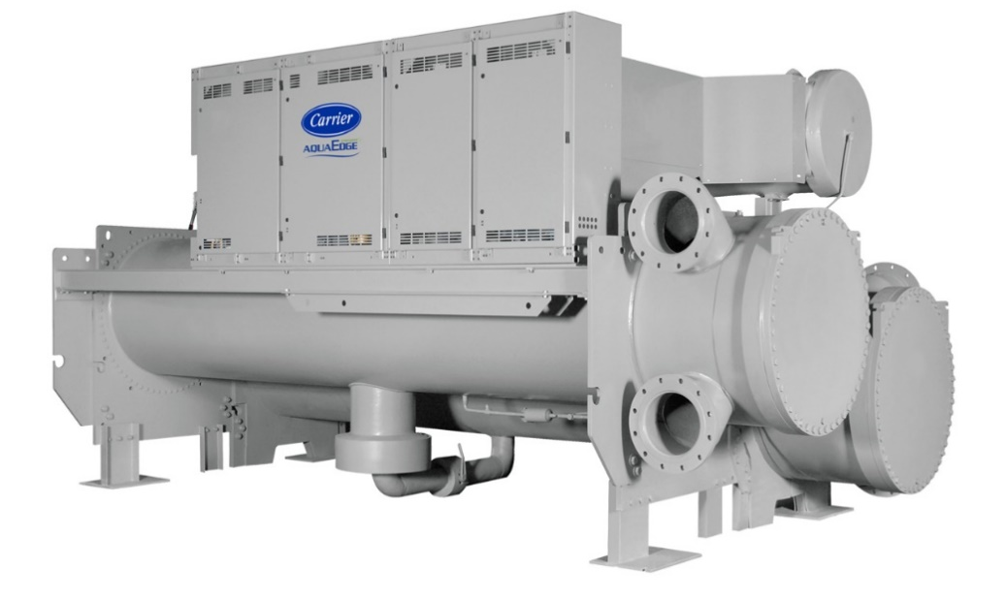
Device Information
Chiller Number | 2511Q20862
Location Name | SHERATON SUITES COUNTRY CLUB PLAZA-770 W 47th St
Location City | Kansas City
Postal Code | 64112-1802
Site Address | 770 W 47th St, Kansas City, MO
Time-zone | America/Chicago
Year of Manufacturing (Age) | 2011(13 Years)
Model Number | 19XRV3130266BHH64-
Report Duration | 2022-01-06 ~ 2023-12-24
Chiller Run Hours | 33,388

Summary
As part of Carrier’s connected chiller program our command center experts continuously monitor performance and health of your chiller and its major components to provide real time feedback and less operational disruption.
Your chiller serial number 2511Q20862 was evaluated for Chiller Replacement Analysis. Further Analysis is performed from the real time data from 2022-01-06 to 2023-12-24. The design efficiency of current chiller is 0.63 kW/T. The overall efficiency of this chiller is 0.5 kW/T. Replacing this with a Carrier Aqua Series Water Cooled Chillers can improve the overall efficiency to 0.4 kW/T. This replacement can improve the chiller efficiency by 20%. The chiller is running at low loads (<60% RLA) for 78% during the analysis period and this replacement can enhance design integrated part-load values (IPLV) to as low as 0.39 kW/T.
Chiller Replacement Benefits:
- Improved Efficiency
- Reduces operating expenses.
- Easy to maintain.
- Quiet operation
- Reliable operation
- Environmentally sustainable refrigerant
- ASHRAE 90.1 compliant
- High-efficiency optimization
- Diagnostic controls
Based on the performance of the chiller operation versus measured parameters, Carrier recommends further evaluation of the Chiller Replacement by our certified technician. This will ensure optimal performance of the Chiller.
Alarm/Setpoint Analysis
There are no alarms during this period.

The analysis result show that setpoint not meeting 6% of time.
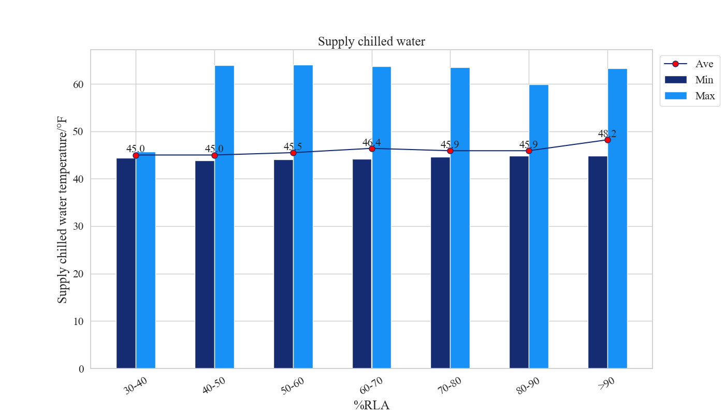
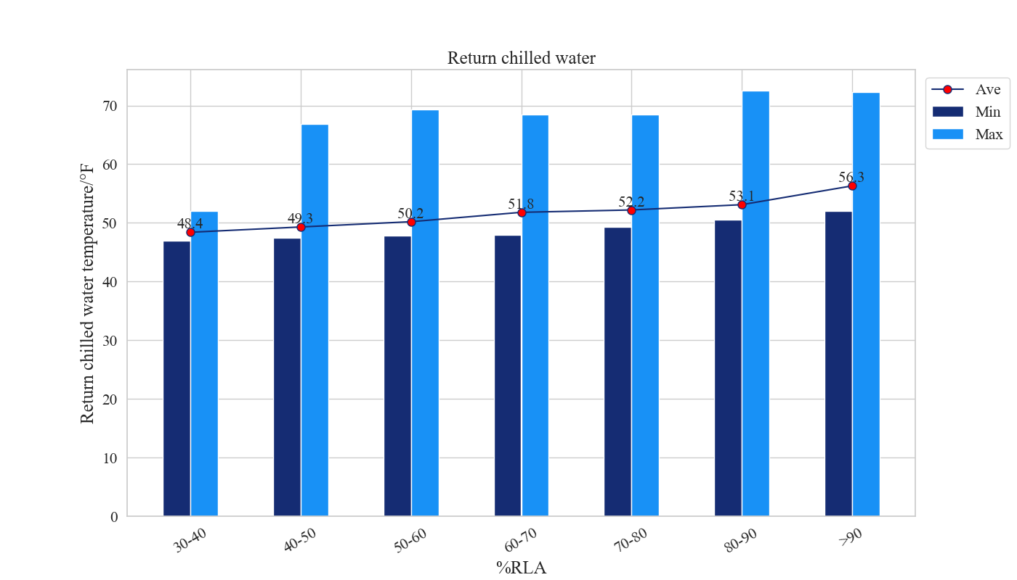

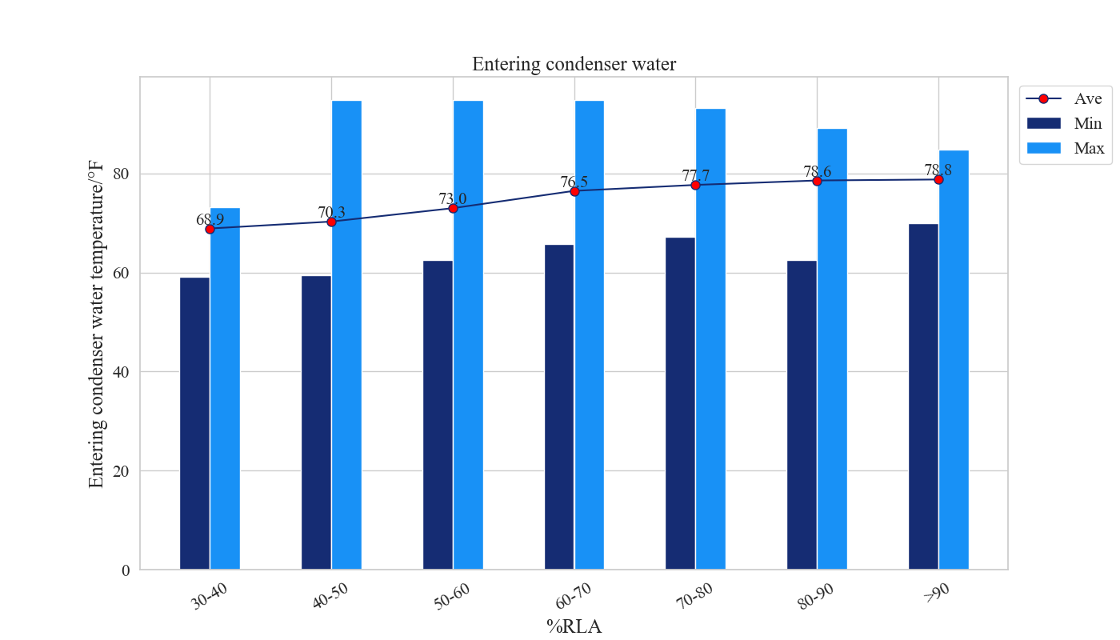
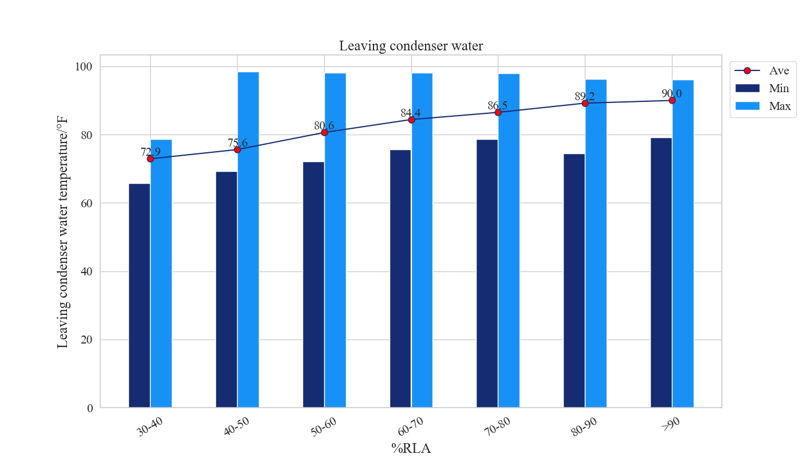
Comments
The Average Cooler supply water temperature is between 45 to 48.2 (°F) and the average Condenser entering water temperature is between 68.9 to 78.8 (°F).
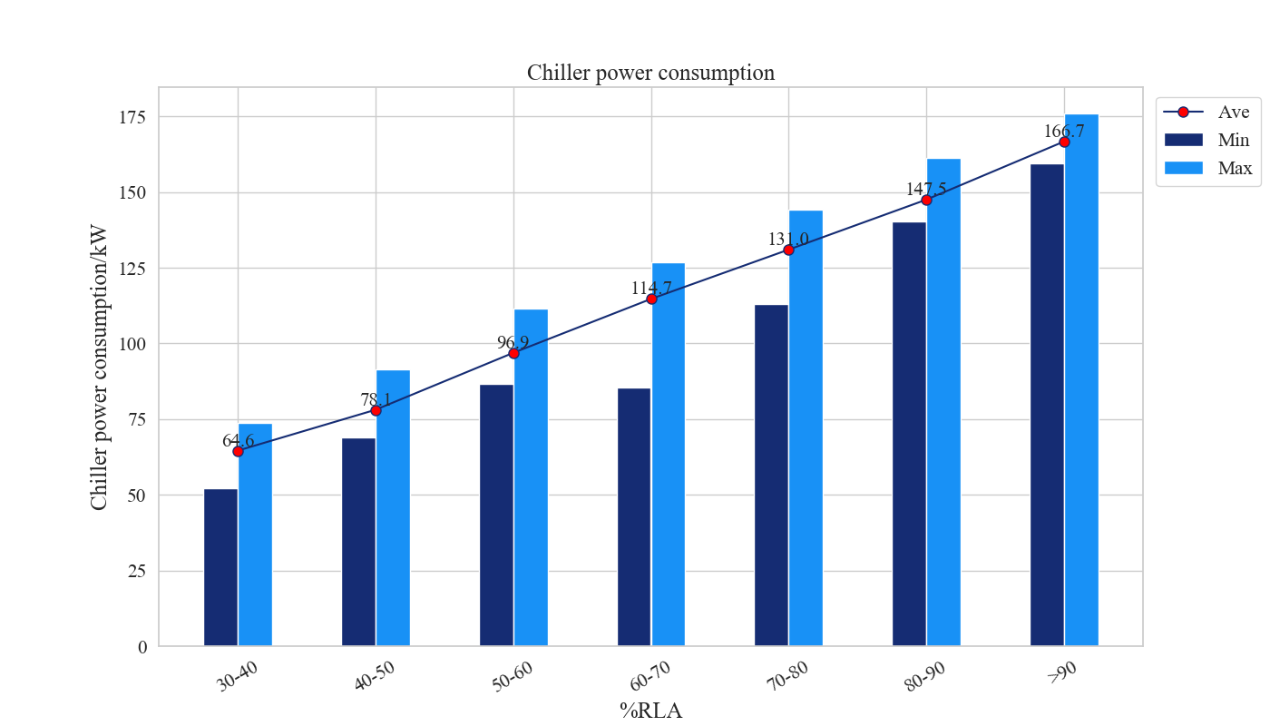
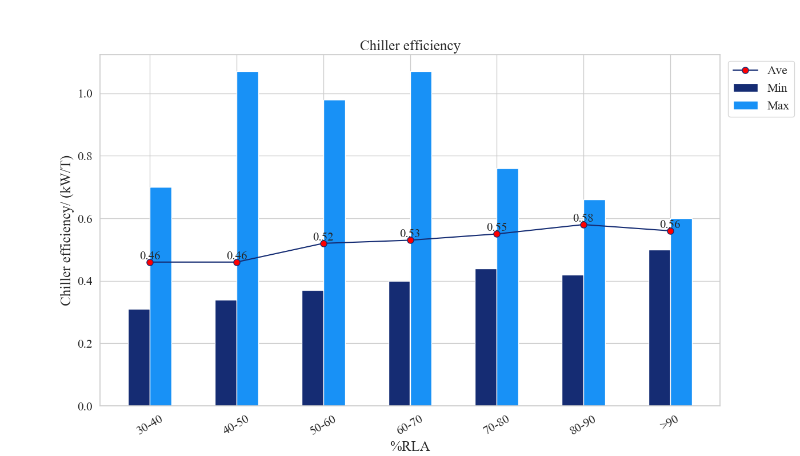
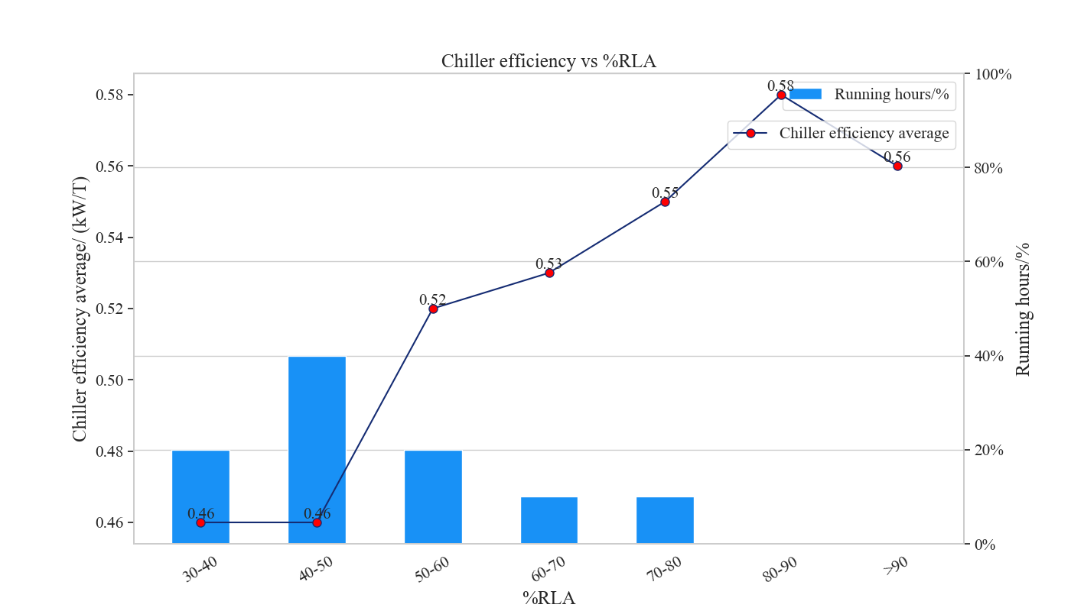
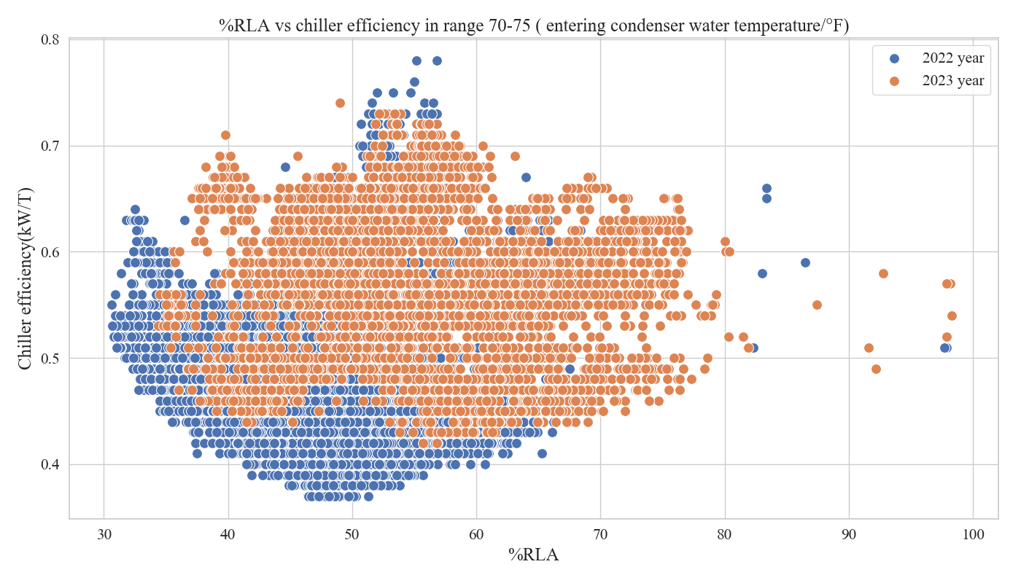
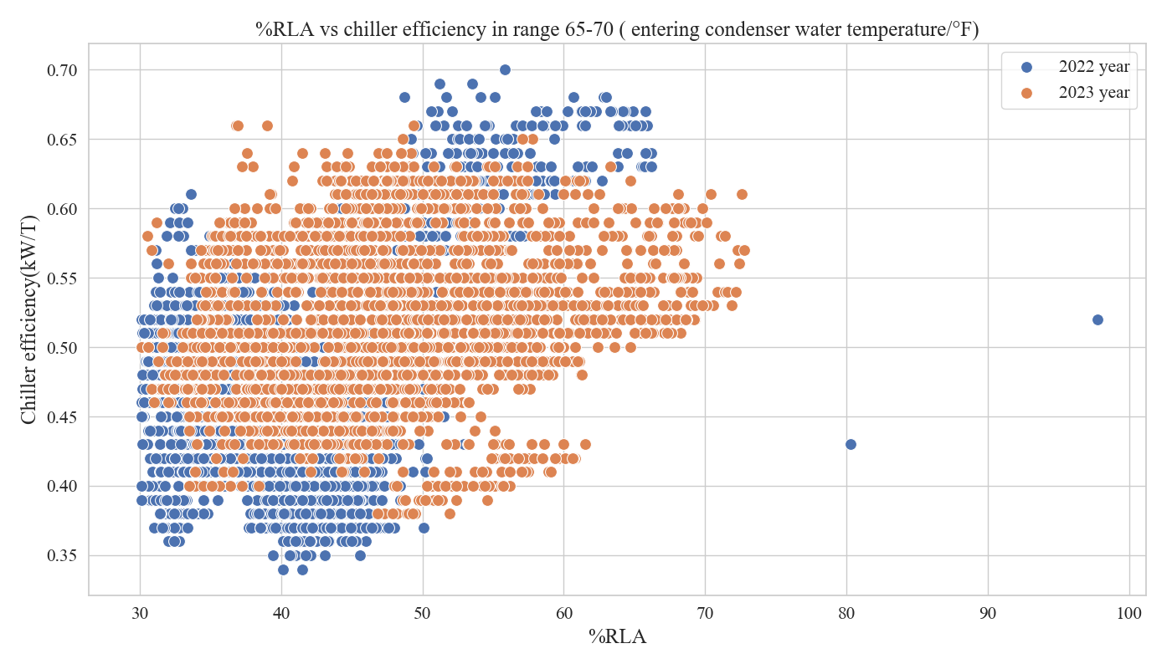
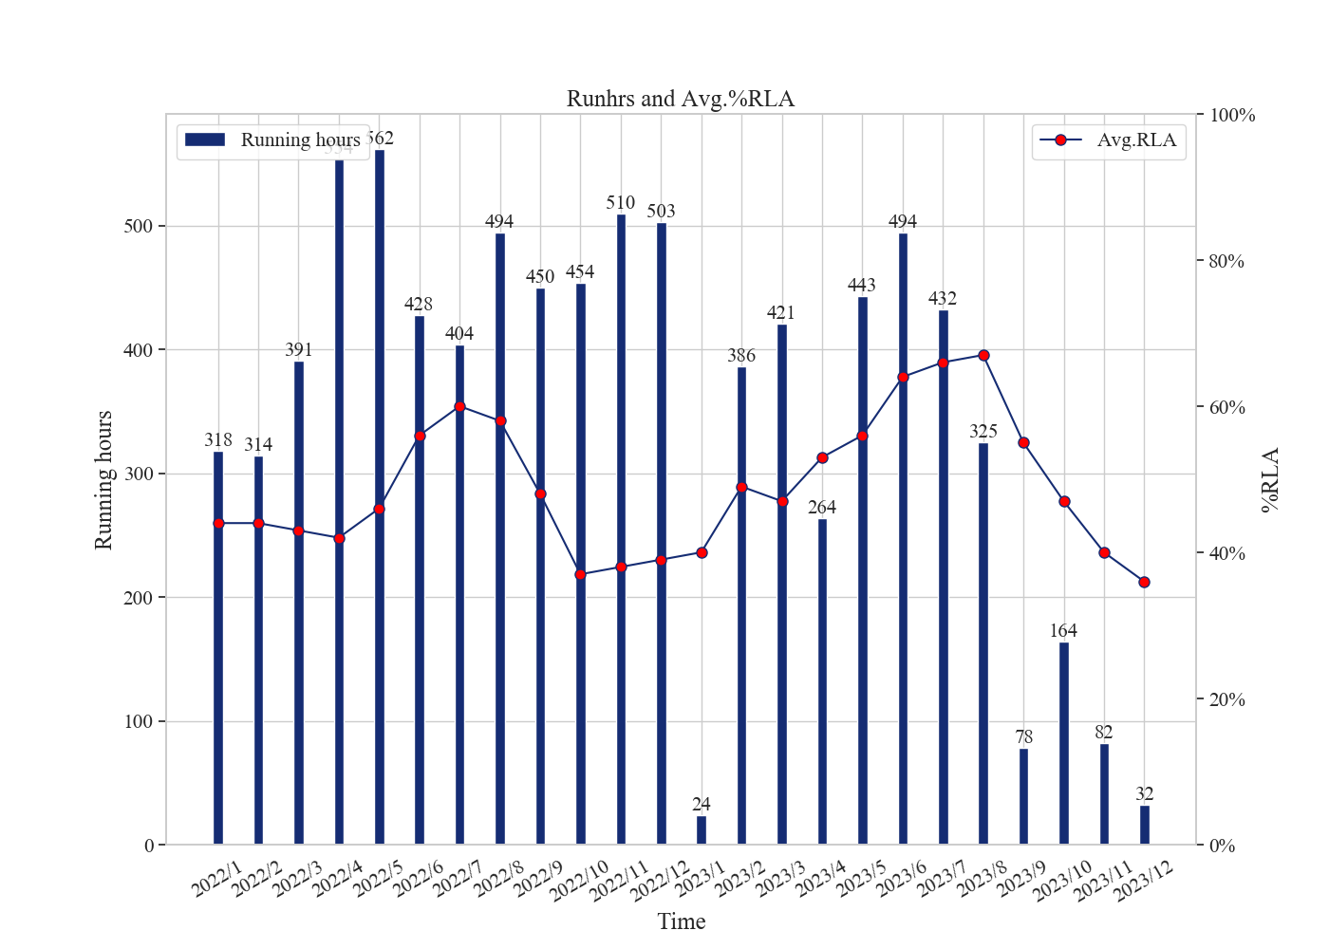
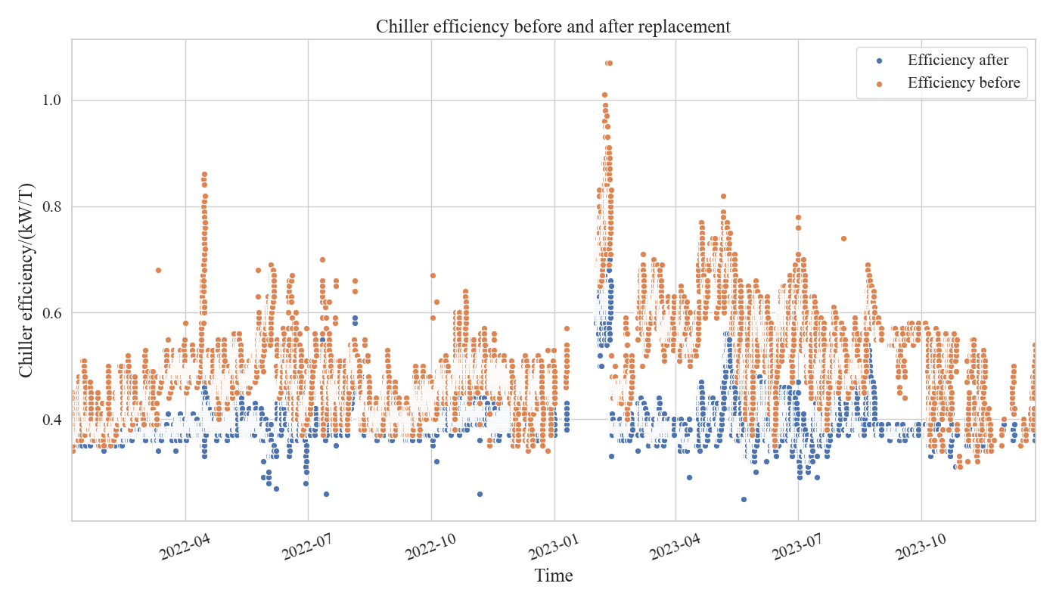
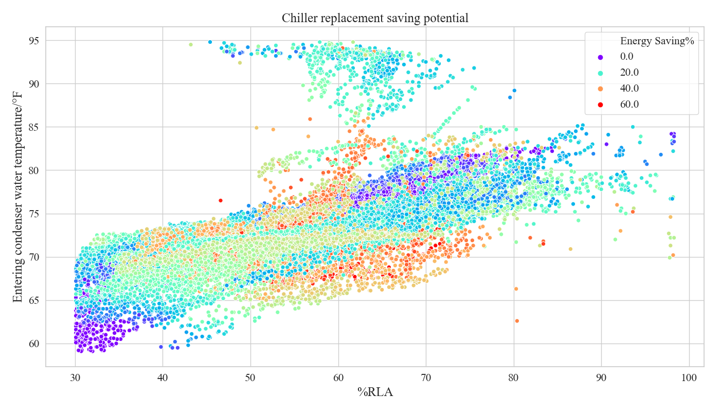
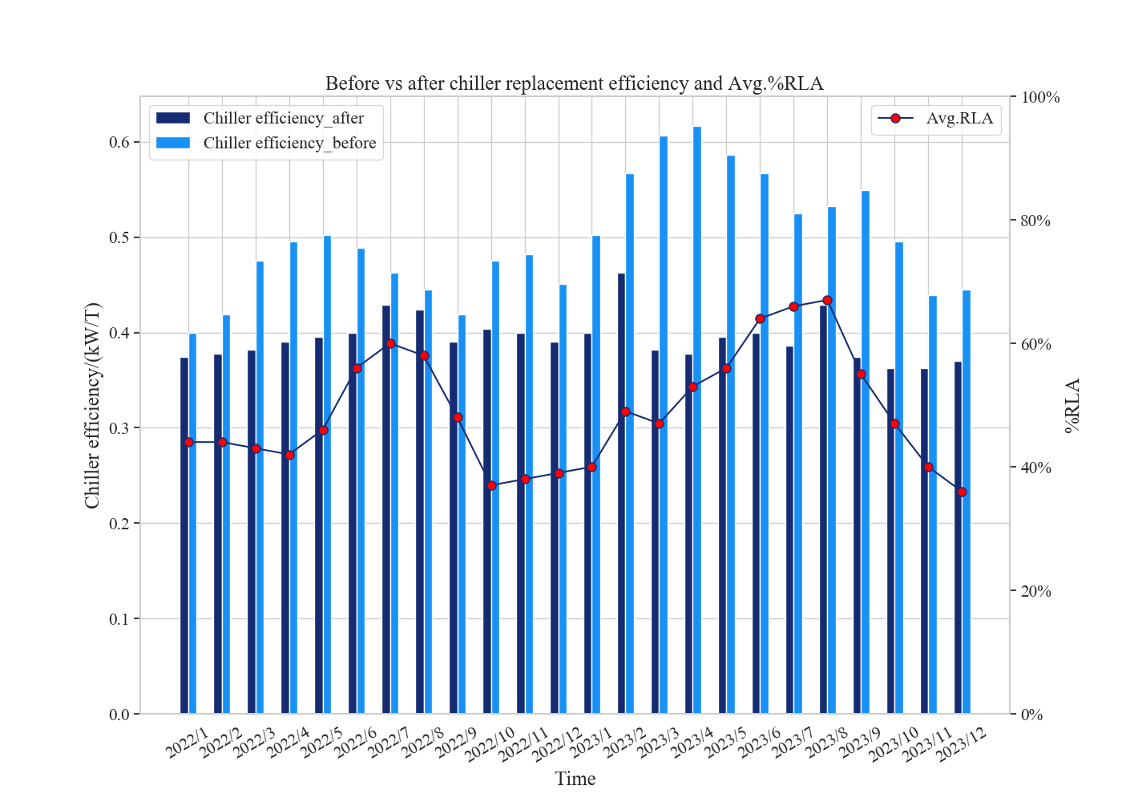
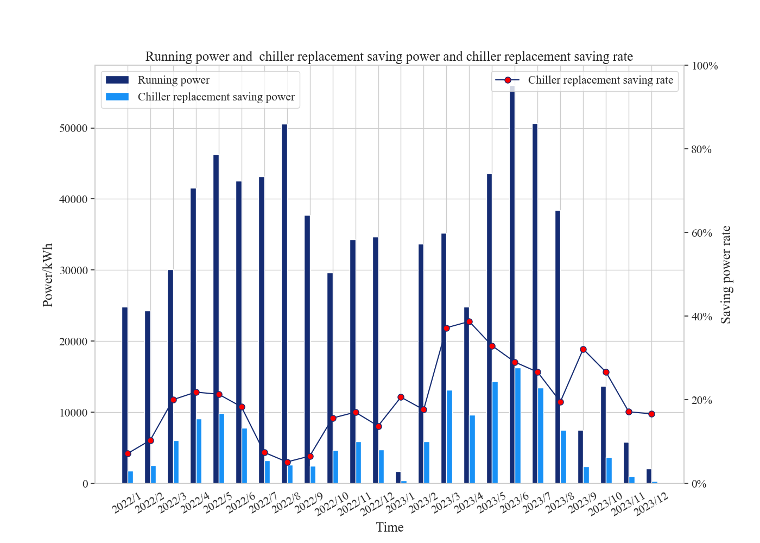
Chiller Sub System Health

Chiller # |  | Condenser Health (Good/Stage of Degradation) | Evaporator Health (Good/Stage of Degradation) |  | Compressor Performance (Good/Stage of Degradation) | Ref leak (Good/Stage of Degradation) | Condenser Water Flow Issue (Yes/No) | Evaporator Water Flow Issue (Yes/No)
2511Q20862 |  | S2
S1 | No action required
S2 | Plan to clean/fix
S3 | Clean/Fix immediately
S4 | -
Summary
Energy Efficiency Improve | 20%
Energy Savings | 148,400 kWh
Energy Savings/per year | 75,545 kWh
Investment pay-back period | 9.9 Years

